Ideation Phase
Define the Problem Statements

Date | 28 September 2026
Team ID | SWTID-2026-5228
Project Name | Import Data using Transform Maps (Spreadsheet)
Maximum Marks | 2 Marks

Customer Problem Statement Template:
Create a problem statement to understand your customer's point of view. The Customer Problem Statement template helps you focus on what matters to create experiences people will love.
A well-articulated customer problem statement allows you and your team to find the ideal solution for the challenges your customers face. Throughout the process, you’ll also be able to empathize with your customers, which helps you better understand how they perceive your product or service.
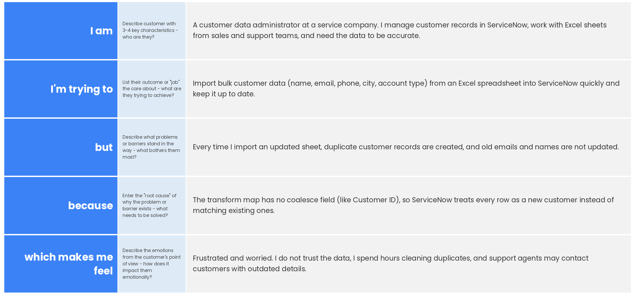
Reference: https://miro.com/templates/customer-problem-statement/
Example:
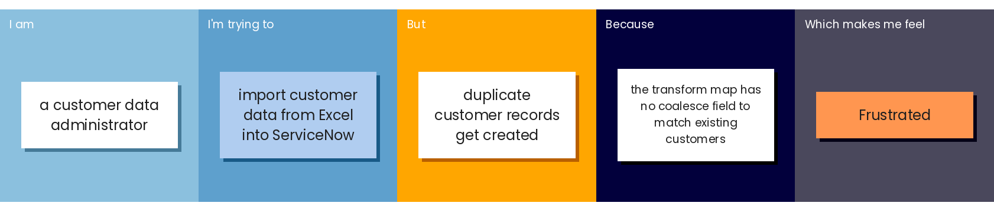
Problem Statement (PS) | I am (Customer) | I’m trying to | But | Because | Which makes me feel
PS-1 | A customer data administrator | Import bulk customer data from Excel into ServiceNow and keep it up to date | Duplicate customer records get created and old details are not updated | The transform map has no coalesce field (e.g., Customer ID) to match existing customers | Frustrated and worried about data accuracy
PS-2 | A customer support manager | View accurate customer reports by city and account type | The report counts look inflated and some customer details are outdated | Duplicate records from repeated imports are counted more than once | Confused and unsure which numbers to trust

